**Whispers of Light – Midterm Business Plan Review**Srujal Patel  
Divya Rana  
Gaurav Vedak  
Kavya Shah  
Veysel Toprak  
Game Content Creation (GAM536)  
Professor Leonardo Moura  
Midterm Project  
June 30, 2025

# Game Development Progress

Whispers of Light has grown from a creative concept into a partially realized technical demo featuring optimized models, custom materials, lighting systems, and Blender Python scripting. Key assets like the Shrine of Memories and the Lantern have been optimized for real-time performance, with stylized textures, UV mapping and shader-based lighting integrated across the scene.

Blender scripting was used to enhance and automate key areas of the scene-building process. Scripting tasks included: (1) placing lantern objects in a circular pattern using math functions (sine, cosine), (2) renaming duplicated objects for cleaner hierarchy management, (3) toggling lighting conditions (sunlight to moonlight), and (4) importing external assets via scripting. These scripts not only saved time but reduced manual error and aligned with the meditative tone of our game design.

With scripting and scene creation now integrated, Whispers of Light feels closer to a vertical slice than ever before, blending symbolic narrative, player interaction, and technical polish into one experience.

# Target Audience & Marketing Strategy

Our target audience consists of players aged 16 to 30 who are drawn to narrative exploration games like Journey, Gris, and Spiritfarer. This demographic values calm gameplay, emotional storytelling, and visual artistry.

Our marketing approach focuses on low-cost but high-impact indie channels. We'll post short narrative trailers and development reels on TikTok, YouTube, and Instagram. A Discord community is being created for playtesting and feedback, and we plan to distribute a devlog newsletter to grow long-term interest.

To differentiate our project, we're focusing on the visual poetry of exploration—allowing light and space to communicate emotional depth. Our tagline, “A luminous journey through forgotten memories,” expresses our core brand.

# Monetization & Development Costs

Whispers of Light will use a one-time purchase model priced at $9.99 to $14.99 CAD, with no microtransactions. This suits our emotionally-driven story and ensures trust with players. One optional post-launch DLC ($4.99) may extend the game.

Scripting tools and Blender are free, but production requires budget consideration for sound assets, marketing, and distribution.

Estimated Costs (CAD):  
- Blender/Tools: $0 (Free)  
- Unity License (if upgraded): $250  
- Sound/Music Assets: $150  
- Marketing & Promo: $100–150  
- Distribution (Steam Direct, etc.): $100  
- Total: ~$700

We aim to break even within the first 100–120 copies sold, with potential profitability in the 6–12 month window post-launch.

# Next Steps & Development Milestones

We plan to complete the full scene export for integration into Unity or Unreal. Remaining tasks include:

- Adding environmental scripting (memory reveal triggers)  
- Finalizing visual transitions using light  
- Recording player testing feedback  
- Refining documentation and creating a final pitch deck

We also plan to enhance camera scripting, prepare Steam/itch.io pages, and begin pre-marketing outreach. Final deliverables will include polished renders, gameplay clips, and a full demo walkthrough.

**Day Lighting Screenshots**

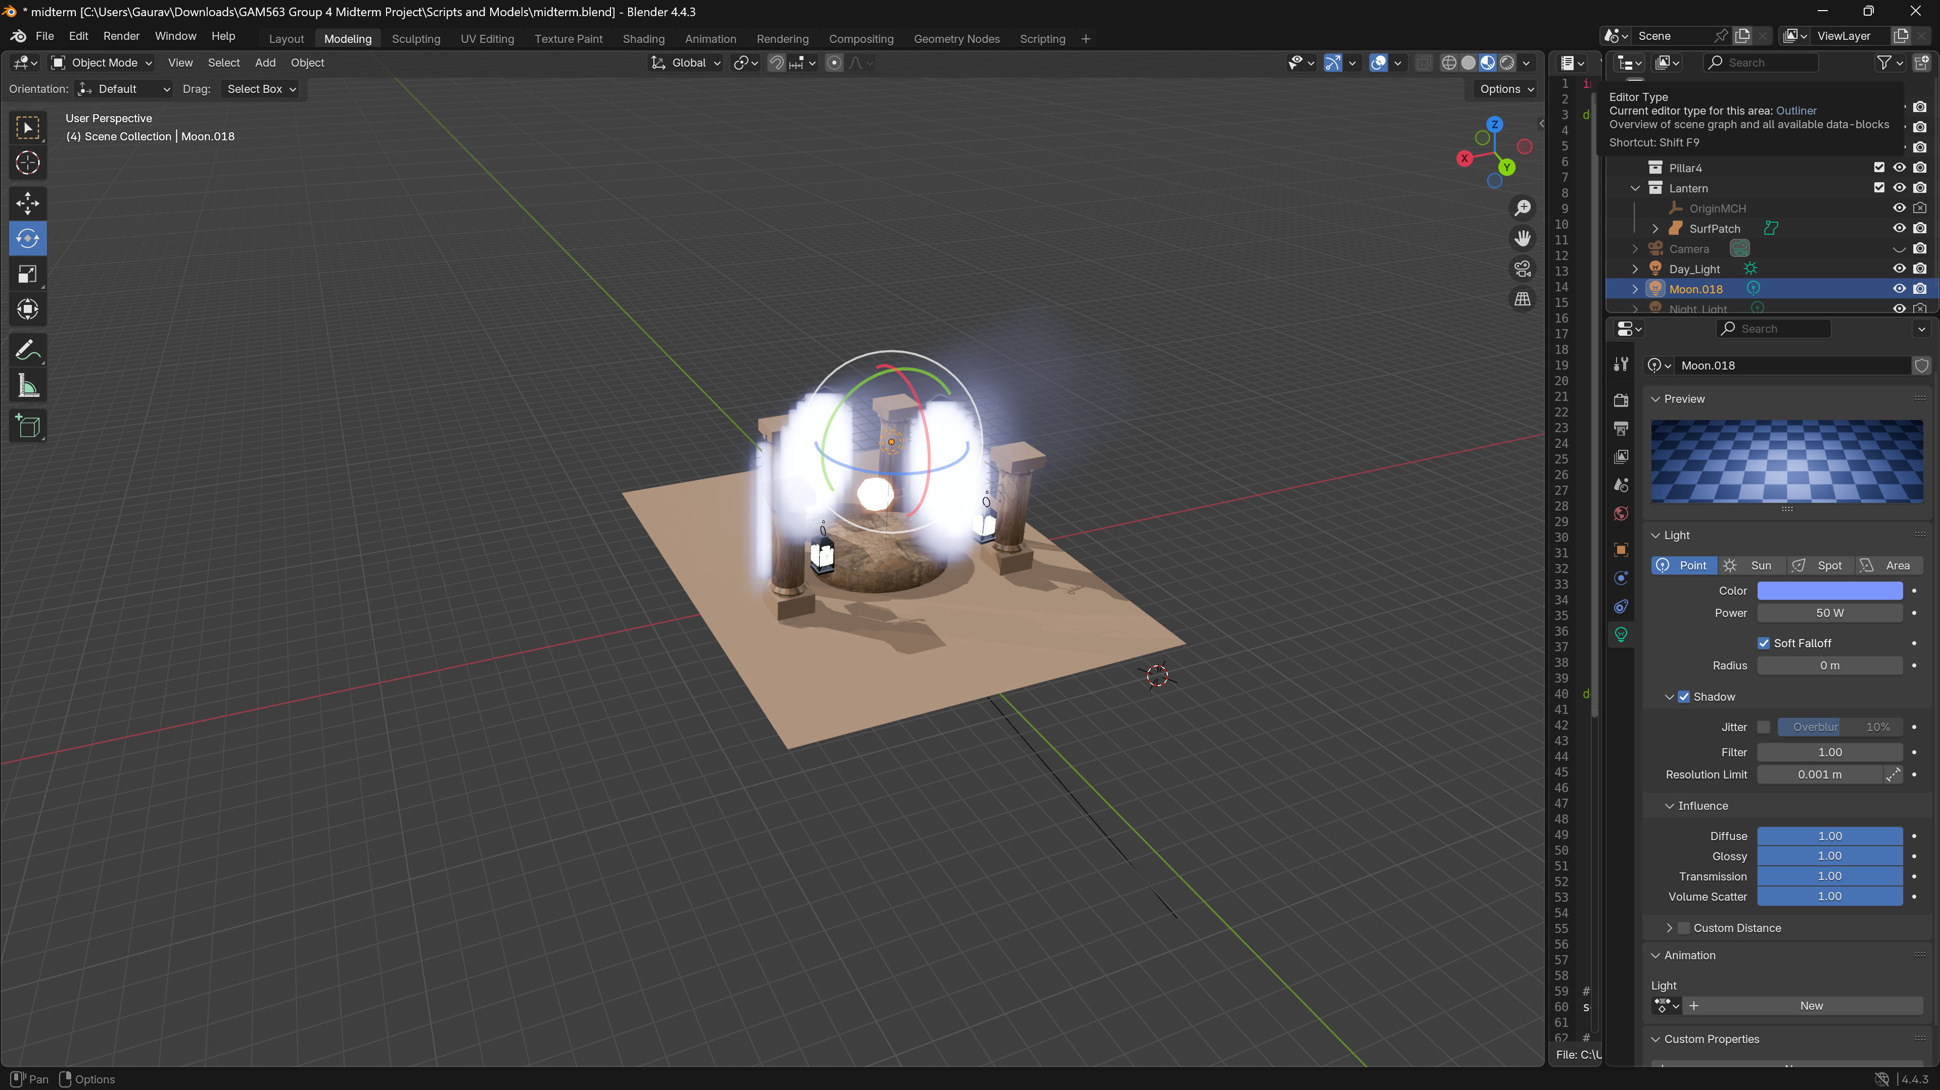

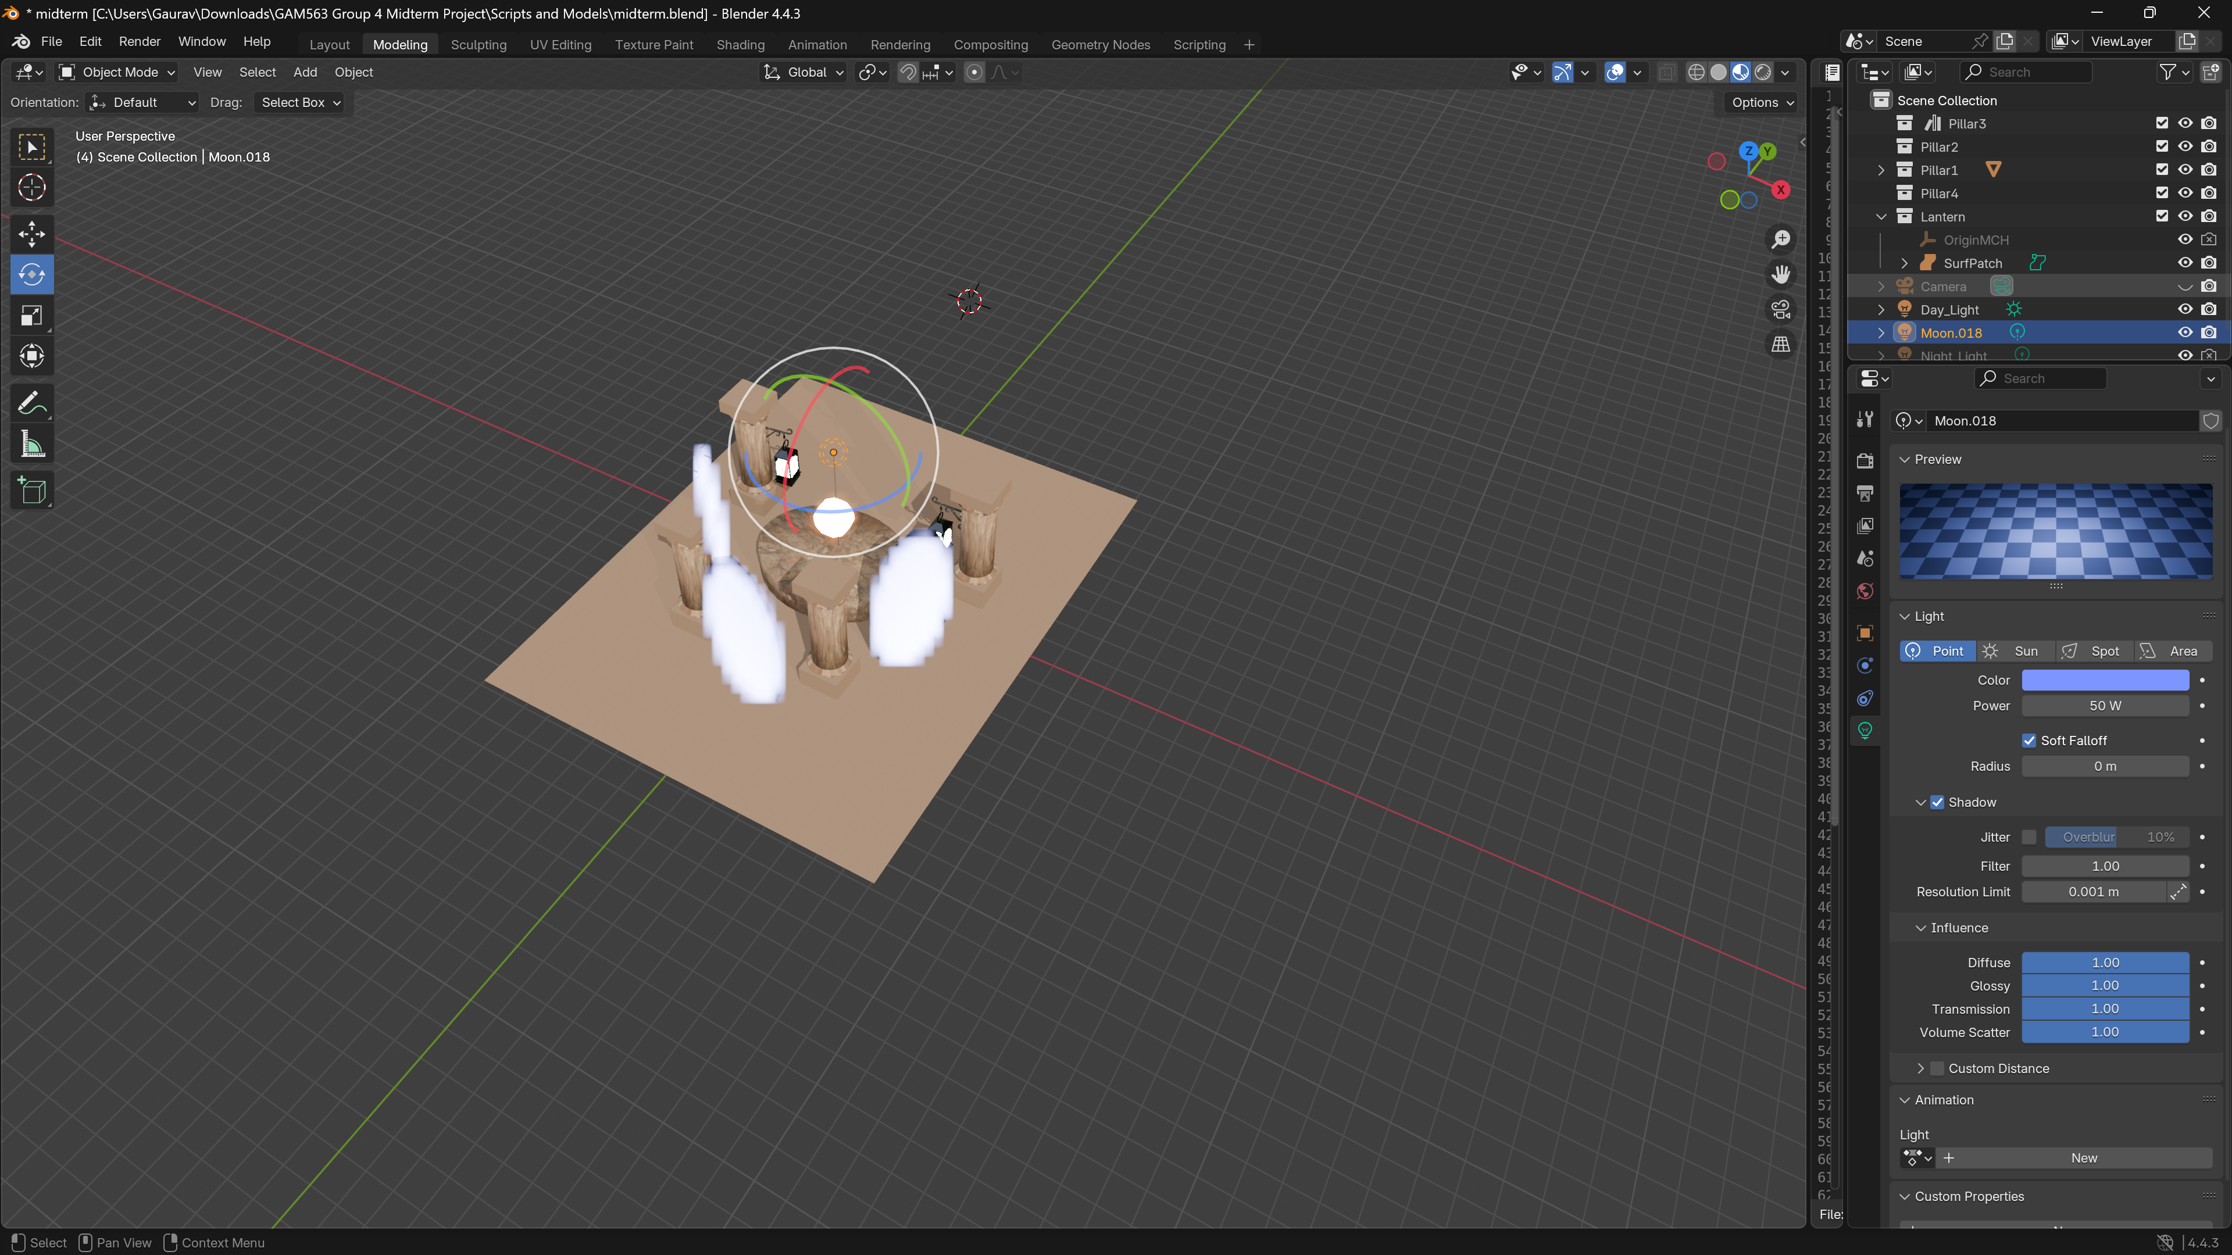

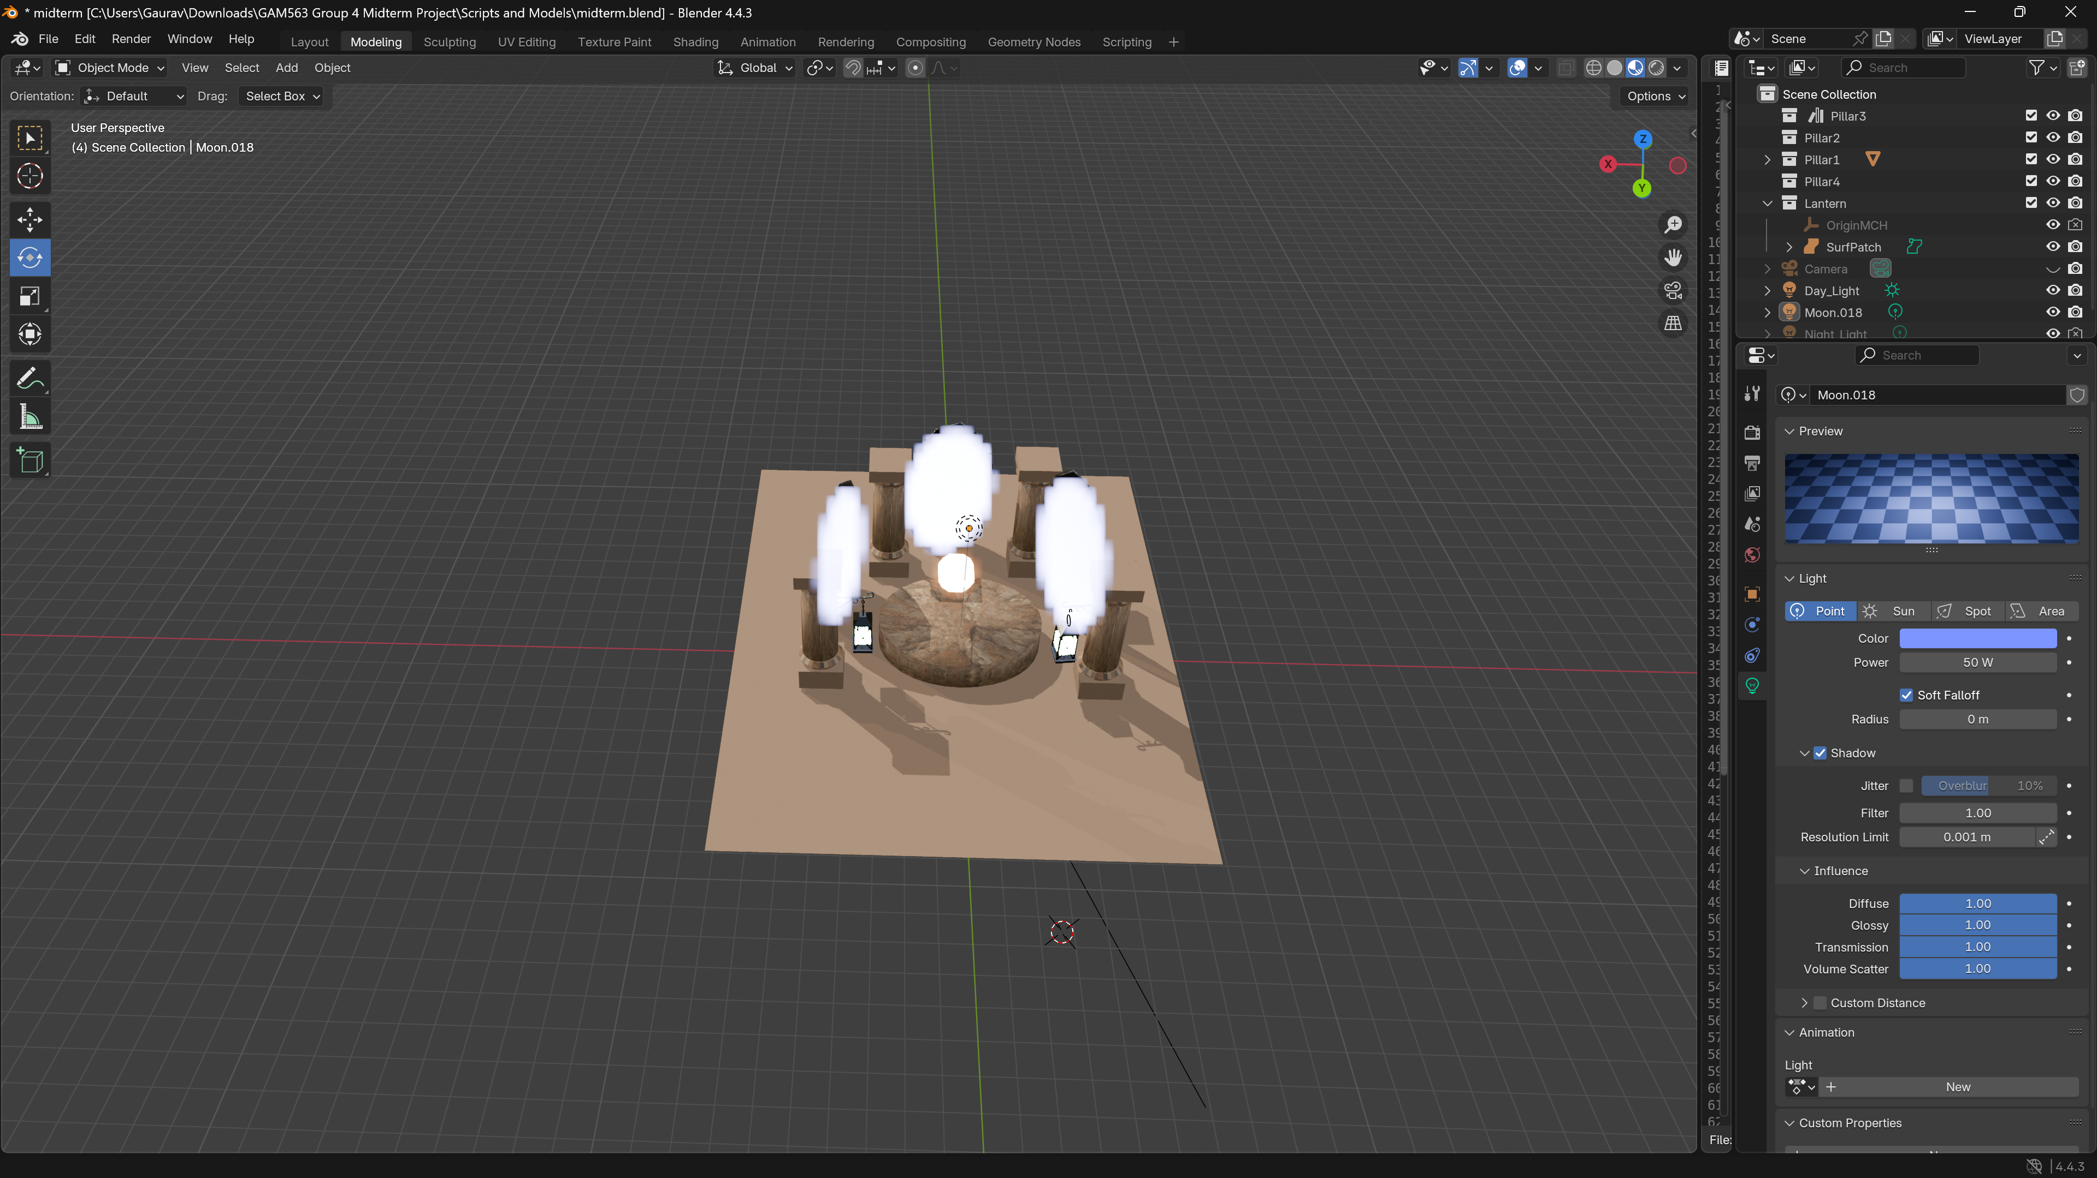

**Night Lighting Screenshots**

